# Exercise: Basic Linux & Bash commands

On Hyper-V/Oracle/VMware (whatever your preferred Linux workaround is currently) download Ubuntu image and install it as a virtual machine or WSL2. After this is done:

1. Create a file friends.txt with a list of names of three of your friends on separate lines.

Cat << EOF > friends.txt

1. Aleksandar
2. Davor
3. Nikola

EOF

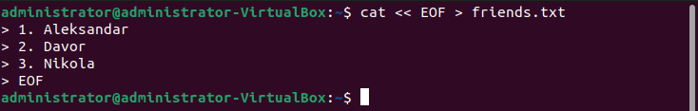

2. Display the contents of friends.txt on the console.

echo “$(<friends.txt)”

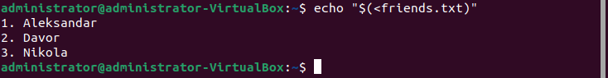

3. Rename file friends.txt to bestfriends.txt

mv friends.txt bestfriends.txt



4. Make a copy of bestfriends.txt under the name sysadmins.txt

cp bestfriends.txt sysadmins.txt



5. List all files whose name begins with letter 'b' and ends with extension txt.

ls b*.txt



6. Write a command that will tell you how many bytes are taken up by file sysadmins.txt

du -b sysadmins.txt | cut -f -1



7. Create file cars.txt with a list of 5 brands of cars on separate lines.

cat << EOF > cars.txt

1. Audi
2. BMW
3. Nissan
4. Kia
5. Opel

EOF

8. Check how many bytes are taken up by the file.

du -b cars.txt | cut -f -1



9. Copy the file cars.txt into directory /tmp

cp -v cars.txt /tmp



10. List all files with extension *.txt in directory /tmp and verify that the file was copied properly.

ls /tmp/*.txt



11. Without leaving your home directory rename file cars.txt located in /tmp to vehicles.txt in /tmp

mv /tmp/cars.txt /tmp/vehicles.txt



12. Display the contents of /etc/passwd file on the screen interactively (so you can search, scroll up and down)

less /etc/passwd



